Date …………………… Experiment No………

**PULSE SHAPING AND MATCHED FILTERS**

**Aim:**

To

1. Generate a string of message bits.

2. Use root raised cosine pulse p(t) as the shaping pulse, and generate the corresponding baseband signal

with a fixed bit duration Tb. You may use roll-off factor as α = 0.4.

3. Simulate transmission of baseband signal via an AWGN channel

4. Apply matched filter with frequency response Pr (f) = P ∗ (f) to the received signal.

5. Sample the signal at *m*Tb and compare it against the message sequence.

**Theory:**

Inter symbol interference (ISI) is a form of distortion of a signal in which the symbol interferes with subsequent symbol.The spreading of the pulse beyond its allotted time interval causes it to interfere with neighboring pulses.ISIdegrade the bit and symbol error rate performance in the presence of noise. The causes of ISI are multipath propagation and dispersion of channels. The baseband transmission system is as shown in figure 1.

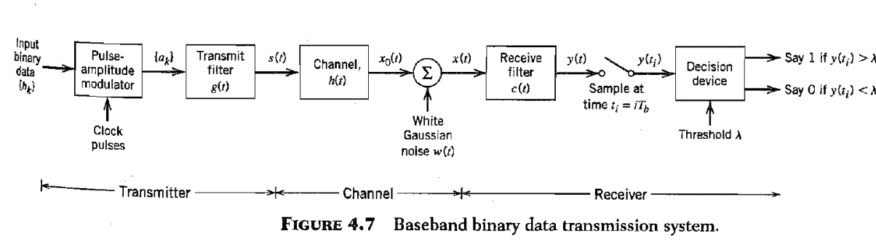

Here,

$$ak=\left\{\begin{matrix}+1, if the symbol b_{k} is 1 \\ -1, if the symbol b_{k} is 0\end{matrix}\right.$$

$$s\left(t\right)=\sum_{k}{a_{k}g(t-kT_{b})}$$

The received filter output is written as

$y\left(t\right)=μ\sum_{k}{a_{k}p\left(t-kT_{b}\right)+n\left(t\right)}$.

Where μ- scaling factor and pulse p(t) is to be defined.

At ith instant

$${y(t}_{i})=μ\sum_{k=-α}{a_{k}p\left[\left(i-k\right)T_{b}\right]+n(t_{i})}$$

$${y(t}_{i})=μa_{i}+\sum_{\begin{aligned}k=-α, \\ k≠i\end{aligned}}{a_{k}p\left[\left(i-k\right)T_{b}\right]+n(t_{i})}$$

The second term is due to ISI.

To avoid ISI Pulse shaping filters are used.Pulse shaping filter must be chosen carefully not to introduce inter symbol interference. The commonly used pulse shaping filters are –

1. Rectangular pulse shape: This pulse shape has poor spectral properties with high sidelobes.
2. Sinc pulse shape: Theoretically, the sinc filter has ideal spectral properties, as the Fourier transform of a sinc function is an ideal lowpass spectrum. However, a sinc pulse is non-causal, hence not realizable.
3. Raised-cosine pulse: This is a pulse widely used in practice. The pulse shape and the excess bandwidth can be controlled by changing the roll-off factor (0≤α≤1, where 0 means no excess bandwidth, and 1 means maximum excess bandwidth)

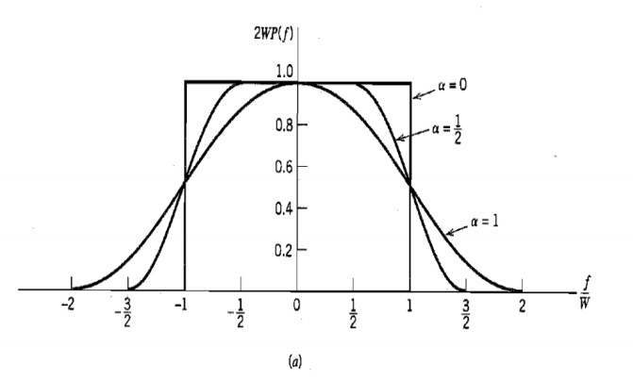

Figure 2. Raised cosine spectrum- frequency spectrum for different $α$ values



Figure 3. Impulse response of Raised cosine filter with various $α$ values

$$h\left(t\right)=\left\{\begin{aligned}\frac{π}{4T}Sinc\left(\frac{1}{2α}\right), t=±\frac{T}{2α} \\ \frac{1}{T}sinc\left(\frac{t}{T}\right)\frac{Cos\left(\frac{παt}{T}\right)}{1-({\frac{2αt}{T})}^{2}}, otherwise\end{aligned}\right.$$

1. Root raised cosine pulse :It has a transfer function equal to square root of raised cosine filter. This filter satisfies Nyquist criteria. These filters are real valued and symmetric. It has its own matched filter.
2. Gaussian filter :The impulse response of this filter is a Gaussian function. Gaussian pulses have good spectral properties.

**Matched filter** :

A matched filter is a filter to provide maximum signal to noise ratio at the output.The Characteristic of the matched filter at the receiver should be complex conjugate of the one at the transmitter in order to fulfill Nyquist criteria. If an RRC filter used at the transmitter, the same filter can be used as it is in the receiver since RRC filter is its own matched filter.

The impulse response of matched filter is h(t)= s(t-τ). Where s(t) is the input.

**Algorithm :**

1. Specify the no.of symbols transmitted
2. Specify the no.of samples of transmitted signal.
3. Generate random binary data and convert it to NRZ format.
4. Oversample each bit by adding 8 samples.
5. Assume the number of taps, roll off rate (alpha) and sample period.
6. Generate a Raised Cosine filter.
7. Perform convolution between raised cosine filter and input signal.
8. Simulate an AWGN channel.
9. Send the convoluted signals through AWGN channel.
10. Generate output after convolution of noise affected signal with matched filter response.
11. Plot the output and compare with transmitted bits.

**Program**(put your program here) :

**Result :**

Put graphs and waveforms here.

The performance of raised cosine pulse shaping and matched filter are simulated.